**FINAL REPORT**

**Capstone Project - The Battle of Neighbourhoods**

1. **Introduction:**

New York City (NYC), often called The City or simply New York (NY), is the most populous city in the United States. With an estimated 2019 population of 8,336,817 distributed over about 302.6 square miles (784 km2), New York is also the most densely populated major city in the United States. Located at the southern tip of the U.S. state of New York, the city is the centre of the New York metropolitan area, the largest metropolitan area in the world by urban landmass. With almost 20 million people in its metropolitan statistical area and approximately 23 million in its combined statistical area, it is one of the world's most populous megacities. New York City has been described as the cultural, financial, and media capital of the world, significantly influencing commerce, entertainment, research, technology, education, politics, tourism, art, fashion, and sports. New York City is composed of five boroughs, each of which is a county of the State of New York. The five boroughs—Brooklyn, Queens, Manhattan, the Bronx, and Staten Island—were consolidated into a single city in 1898.

New York City has also been a major point of entry for immigrants; the term "melting pot" was coined to describe densely populated immigrant neighbourhoods on the Lower East Side. As many as 800 languages are spoken in New York, making it the most linguistically diverse city in the world. English remains the most widely spoken language, although there are areas in the outer boroughs in which up to 25% of people speak English as an alternate language, and/or have limited or no English language fluency. English is least spoken in neighbourhoods such as Flushing, Sunset Park, and Corona.

With its diverse culture, comes diverse food items. There are many restaurants in New York City, each belonging to different categories like Chinese, Indian, and French etc. Lot of tourists all around the world visit the city.

1. **Problem:**

To find the solution to following questions:

1. List and visualize all the neighbourhoods and borough of the New York City.
2. Find the central point of New York where are most of the Indian restaurants.
3. Find hotels in the vicinity of Indian restaurants.
4. **Data Section:**

New York City's demographics show that it is a large and ethnically diverse. With its diverse culture, comes diverse food items. There are many restaurants in New York City, each belonging to different categories like Chinese, Indian, and French etc.

For this project we need the following data:

* New York City data that contains list Boroughs, Neighbourhoods along with their latitude and longitude.
* Data source : <https://cocl.us/new_york_dataset>
* Description: This data set contains the required information. And we will use this data set to explore various neighbourhoods of New York City
* Indian restaurants in each neighbourhood of New York City.
* Data source : Foursquare API
* Description: By using this API we will get all the venues in each neighbourhood. We can filter these venues to get only Indian restaurants.
* Use geopy library to get the latitude and longitude of New York city.

1. **Methodology:**

We begin by using this link: “<https://cocl.us/new_york_dataset> “ to explore the data and find the New York city’s neighbourhood and boroughs.

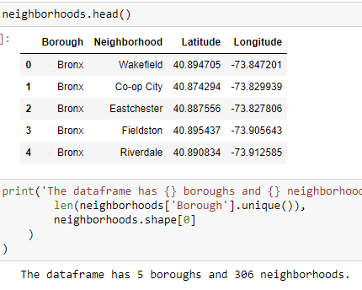

Then we focus on Manhattan as it centre to tourist attraction and has most of Indian Restaurants.

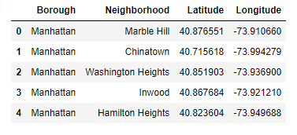

Manhattan’s Map showing the Neighbourhoods using Python’s Folium Library

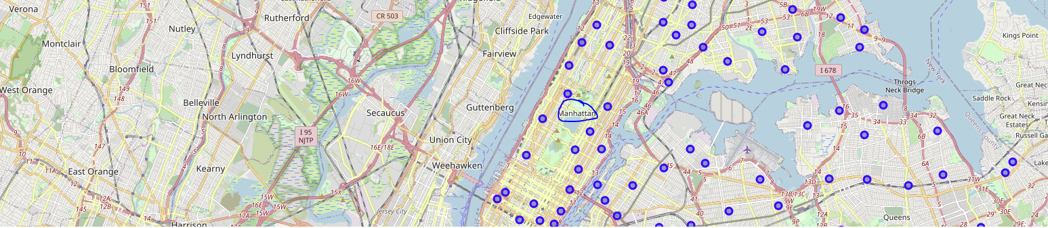

Then we filter out on number of Hotels through foursquare in Manhattan

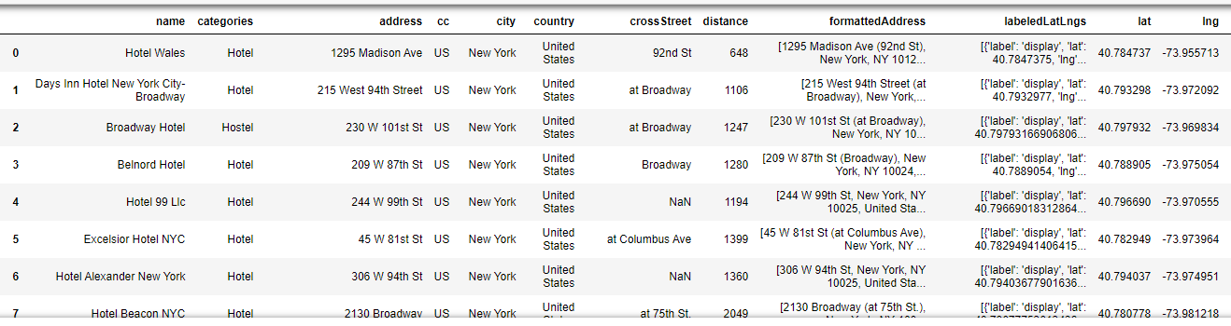

Then I found out number of Indian Restaurants closer to these hotels

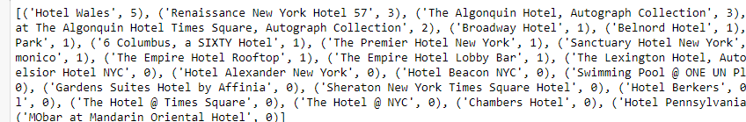

1. **Result:**

We found that there are 5 Indian Restaurants under 10 mile radius of ‘Hotel Wales’ at Manhattan.

1. **Conclusion:**

There is always different ways to find out the solution to problem. I have found a small glimpse of how real life problems could be solved through Data Science.

Finally you have any friend visiting New York, they can use this to find out which hotels would fit best to their dietary need. I have given an example of Indian Restaurant but this can be used to find out any cuisine which a tourist is interested in.